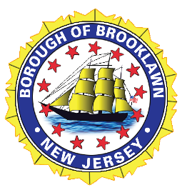
BOROUGH OF BROOKLAWN
Work Session Council Meeting
September 2th, 2026 ~ 6:30 p.m.
Agenda
______________________________________________________________________________
Call to Order

Pledge of Allegiance

Roll Call

Public Notice

This meeting was advertised in accordance with the Open Public Meetings Act, and complies with all the laws therein.

Old Business
Ordinances

Ordinance #7-2027 – Authorizing General Capital Ordinance for $450,000
Ordinance #8-2027 – Authorizing Water Capital Ordinance for $100,000

New Business
Consent Agenda

The items listed below are considered to be routine by the Borough of Brooklawn and will be enacted by one motion. There will be no formal discussion of these items. If discussion is desired, this item will be removed from the Consent Agenda and will be considered separately.

(Motion to approve/deny all Resolutions listed under the Consent Agenda by
Roll Call Vote)

Resolution XX-26 – Authorizing Municipal Liens

Conclusion of New Business

Item of Discussion

- McDonald’s Update
- Shade Tree Appointments
- Revaluation: Tax Maps

Open to Council

Public Portion
(Individuals must state their name and address for the record and respect the five-minute time limit while addressing the Governing Body)

Motion to open _______ 2nd ________
All in Favor

Motion to close _______ 2nd________
All in Favor

(If needed) Executive Session: Resolution No. 114-26 - Excluding public participation within a portion of a meeting of the Borough of Brooklawn pursuant to NJSA 10:4-12

Motion ______2nd _______
All in favor

Meeting Adjournment

Motion _______ 2nd ______
All in favor

Next Council meeting is scheduled for Monday, September 21st, 2026

