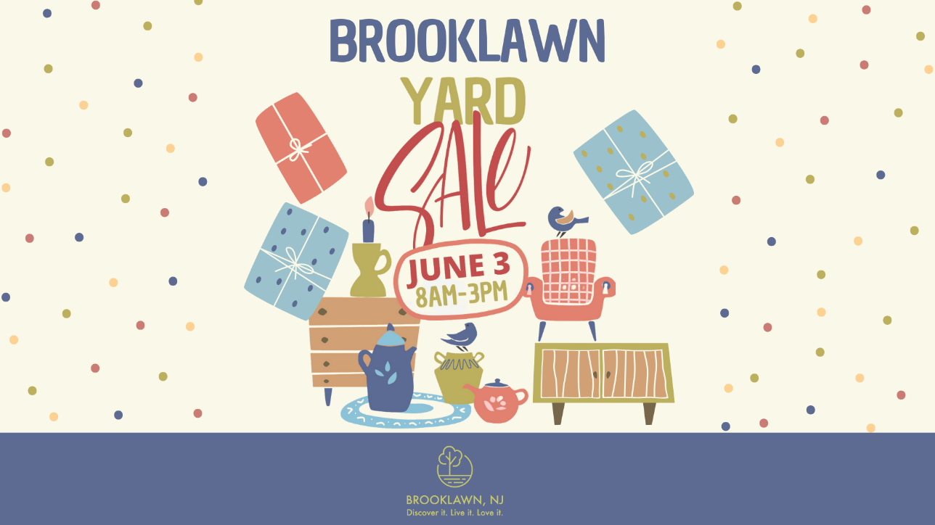

NAME ______________________________________________________

ADDRESS ____________________________________________________

EMAIL ADDRESS ______________________________________________

$5.00 REGISTRATION FEE TO COVER THE COST OF ADVERTISING

______ CASH

______ CHECK: PAYABLE TO BOROUGH OF BROOKLAWN

